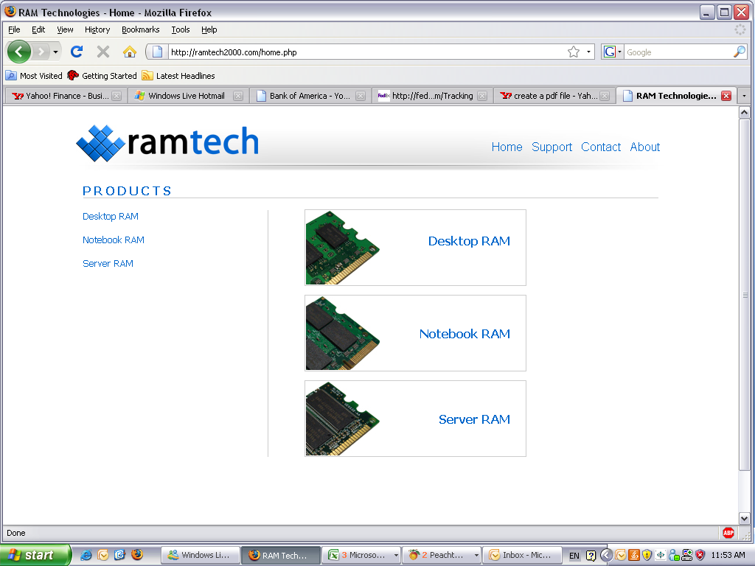
RMA REQUEST FORM
KSE dba RAm technologies  322 PASEO SONRISA, walnut, CA 91789 | rma Number:
Customer Service / rMA Dept.  Tel: (909) 869-8826 FAX: (909) 869-8954  E-mails: RMA@ramtech2000.com Carolyn@ramtech2000.com | RMA# issue date:

Company name: |  |  |  | contact person: |  |  | request date:
address:
TEL: |  |  |  | eMAIL:
fAX:
Replacement  Credit |  |  |  |  | All credit back request are subject for sales personnel and/or sales manager’s approval. RMA number given for Credit request does not guarantee a credit back.  Ram Technologies reserves the rights to deny a credit back even after a RMA number has been issued.
QTY | RAM TECH PART # |  | DESCRIPTION |  | INV DATE | INV # | PROBLEM | RAM TECH USE ONLY

- Please enclose a copy of Ram Technologies RMA Issuing Sheet that contains the RMA# issued by Ram Technologies.
- Reference the RMA # in black bold print on the outside of the box. For multi-pack box, Please reference each RMA #.
- All products must be properly packaged or else Ram Technologies reserves the right to return them to the sender.
- All labels other than Ram Technologies label must be removed before returning. Items without label will not be accepted
- Ram Technologies assumes no responsibility for any loss or damage item.
Page _______ of .

